Functional Scope
Guyana Development Bank – Lending Application



Table of Contents
Table of Contents 2
1. Project Overview 4
1.1 Objective 4
1.2 Statement of Work type 4
1.3 Acronyms used in this SOW 4
2. Scope 5
2.1 Loan Products in scope 5
2.2 Capability overview 5
2.3 Capability detail 7
2.4 Requirement specification index 8
2.5 Human personas 10
2.6 Out of scope 11
3. Indicative Timeline 12
4. Deliverables 12
5. Support Required from CLIENT’s SMEs 12
6. Project Reporting 13
7. Escalation Process 13
8. Key Assumptions 13
9. Dependencies 14
9.1 Program and data dependencies 14
9.2 Technology dependencies 15
10. Detailed Requirement Specification 16
10.1 Requirement summary 16
10.2 Requirement register 16

1. Project Overview

1.1 Objective
Project start date: September 4th, 2026
Project end date: October 14th, 2026

The Guyana Development Bank is a new state-backed development institution created to close the SME financing gap, offering zero-interest, zero-collateral loans of up to G$3,000,000 to Guyanese micro and small enterprises.

This SOW covers delivery of the Guyana Development Bank Agentic Loan Origination Platform.

The platform objectives are:

- Deliver one digital journey from authenticated identity through application, decision, disbursement and servicing, for every in-scope loan product.
- Give each GDB role a purpose-built workspace, with a named human accountable for every credit decision.
  - Borrower
  - Field Officer
  - Facilitator for clusters
  - Sector Specialist
  - Underwriter
  - Disbursement Officer
  - Finance Department
  - Board/CEO
  - Platform Administrator
- Verify applicant, business and compliance data against government registries rather than asking a citizen to re-supply it.
- Produce an auditable, reconcilable record of every state change and every disbursement of public capital.
- Hold product and policy in configuration, so ceilings, sectors and eligibility change without a code release.

1.3 Acronyms used in this SOW
Acronym | Definition
aLOS | Agentic Loan Origination System
AI | Artificial Intelligence
API | Application Programming Interface
CHPA | Central Housing and Planning Authority
DCRA | Deeds and Commercial Registries Authority
DICR | Digital Identity Card Registry
e-ID | Electronic Identification
GDB | Guyana Development Bank
GRA | Guyana Revenue Authority
GRO | General Register Office
GUIN | Guyana Unique Identification Number
GYD / G$ | Guyana Dollar
IAM | Identity and Access Management
ICT | Information & Communications Technology
KYC | Know Your Customer
MOF | Ministry of Finance
NIS | National Insurance Scheme
RIDN | Resident Identification Number
SME | Small and Medium Enterprise
TIN | Taxpayer Identification Number
UAT | User Acceptance Testing

2. Scope
This section covers the detailed scope of application includes the Products, Capabilities which constitute functional by persona, operational & administration capabilities and technology & AI capabilities.

2.1 Loan Products in scope

 | Product | Ceiling | Rate | Applies to | Status
P1 | SME Direct Loan | Up to G$3,000,000 | 0% | Sole proprietor, incorporated company, cluster member | In scope
P2 | Quick Loan | Up to G$300,000 | 0% | Informal sellers | In scope
P3 | Co-financed Facility | Up to G$7,000,000 | Preferential, set with the co-financing bank | Businesses requiring capital beyond P1 | Out of scope for MVP — deferred
The ceiling is a maximum limit - the applicant is not entitled to the ceiling amount. The Underwriter determines the approved amount up to the ceiling by verifying eligibility and assessing risk. Ceilings, rates and eligibility are held in configuration.

2.2 Capability overview

The following are the holistic view of capabilities being provided by the lending platform; experience/engagement, operational, underwriting, common and AI capabilities.
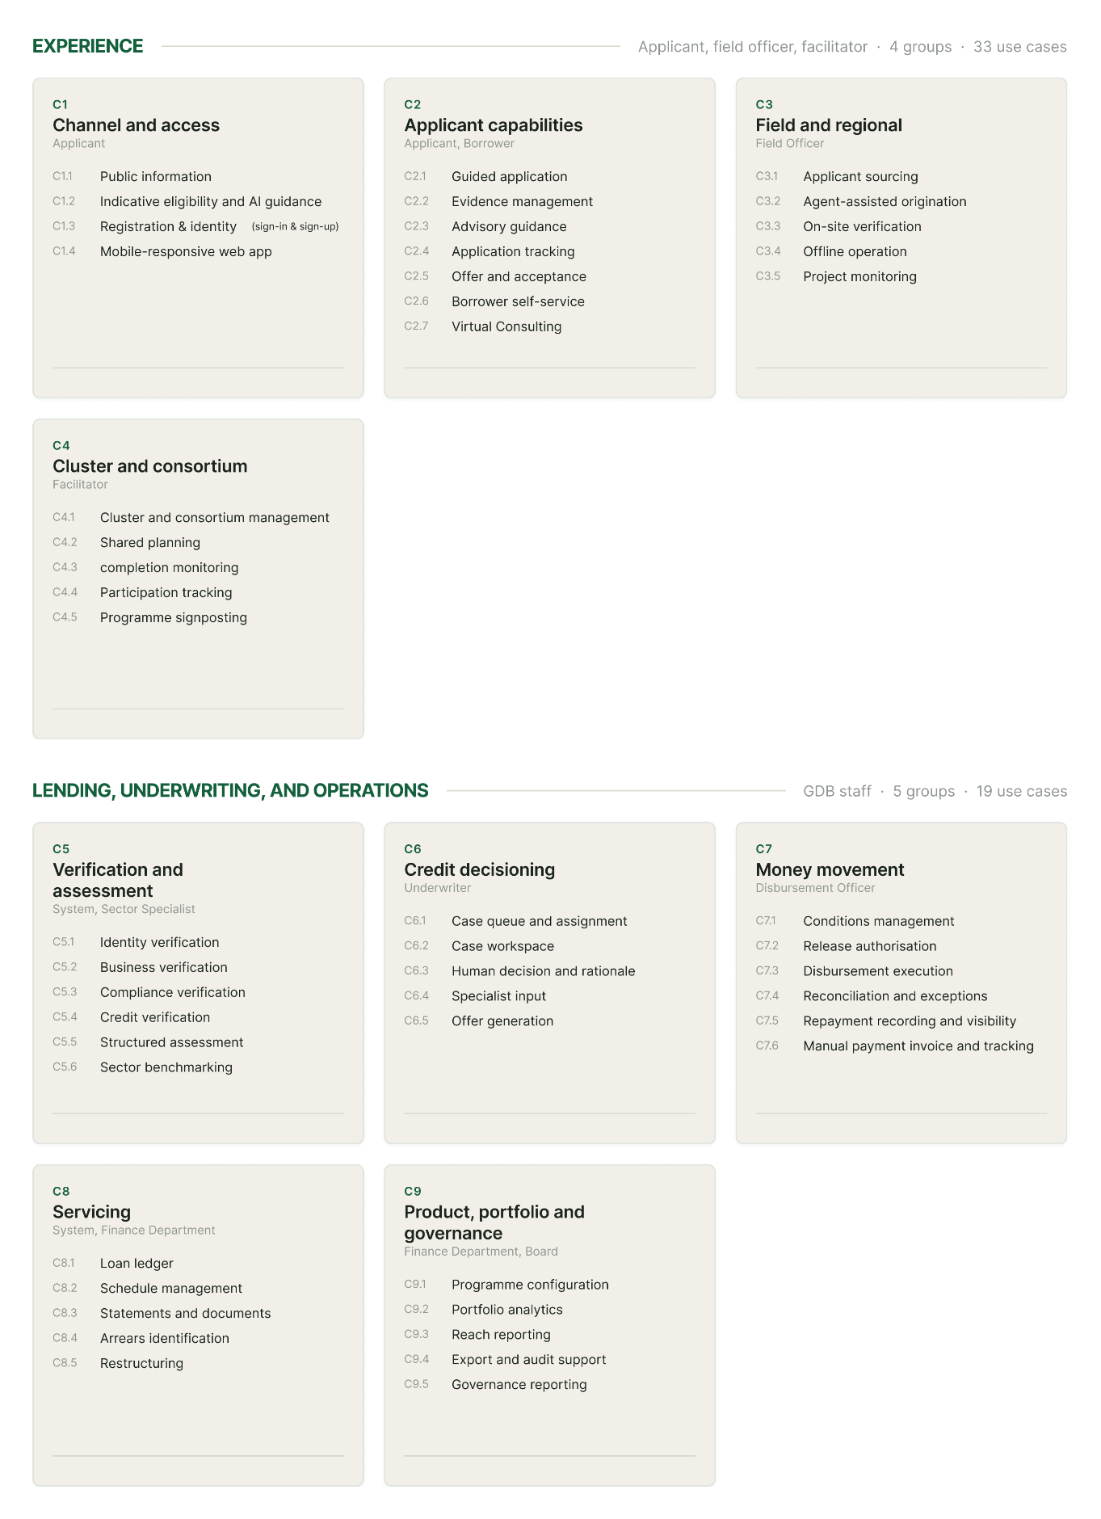
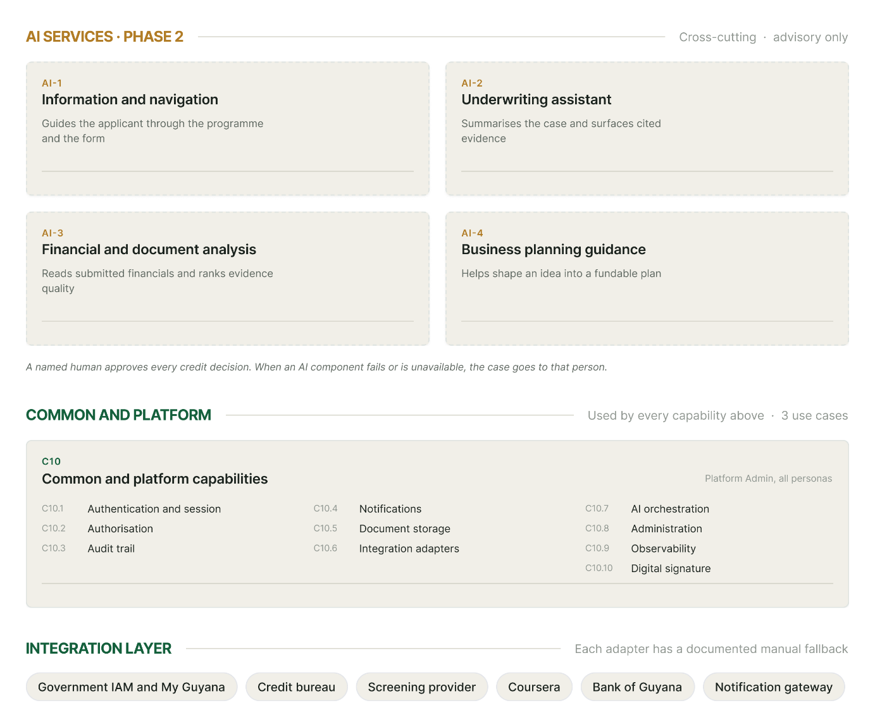

2.3 Capability detail
What each capability group covers and who owns it. Every capability identifier links to its requirements in section 11.2.

ID | Capability | What it means | Primary owner
C1 | Channel and access | Everything a citizen meets before they hold an application: what the program offers, whether they are likely to be eligible, and how they register and are identified. Identity is consumed from My Guyana; no citizen credential is created here. | Applicant
C2 | Applicant capabilities | The applicant's own workspace — a guided application for an existing business or a new venture, evidence capture, mandatory training, tracking, offer acceptance, and borrower self-service once the facility is funded. | Applicant, Borrower
C3 | Field and regional capabilities | What a regionally based officer does away from the portal: sourcing applicants, originating on their behalf with recorded consent, verifying on site, working with no connection, and monitoring funded projects. | Field Officer
C4 | Group and capability building | Clusters and consortia — creation by the cluster head, member invitation and independent sign-in, shared planning with member sections kept separate, and training completion monitored across the roster. | Facilitator, Cluster head
C5 | Verification and assessment | Checking what the applicant declared against the government registries, the credit bureau and the screening provider, then producing a structured assessment in which verified evidence outranks self-declared evidence. | System, Sector Specialist
C6 | Credit decisioning | The underwriter's workspace and the recorded human decision: queue and assignment, case evidence with citations, rationale and approved amount, specialist referral, and maker-checker on approval. | Underwriter
C7 | Money movement | Moving public capital and recording what comes back: conditions precedent, release authorization, disbursement execution to a verified account, reconciliation and exception handling. | Disbursement Officer
C8 | Servicing | The life of the facility after disbursement — an append-only ledger, schedules and statements, balances and arrears derived at read time rather than stored, and authorized restructuring with the prior schedule retained. | System, Finance Department
C9 | Product, portfolio and governance | Product and policy held in configuration and referenced everywhere is applied, plus portfolio, reach and governance reporting to GDB Finance, the Board and the CEO. | Finance Department, Board
C10 | Common and platform | The shared foundation is every other capability sits on authentication, authorization, audit trail, notifications, document storage, integration adapters, administration and observability. | Platform Admin, all personas
CA | AI services | Four assistive capabilities delivered under the follow-on engagement in §3.3. No AI component records, makes or influences a credit decision without a named human approving it, and every AI failure routes to a person. | Advisory to Underwriter and Applicant
CI | Identity and access | Identity resolution and access control treated as one cross-cutting concern: the permanent person key, national-ID fallback and later upgrade, consent capture, session separation and least-privilege scoping. Largely realized inside C1 and C10. | Platform Admin, all personas

2.4 Requirement specification index
Each feature inside each capability, the requirements that realize it and the target phase. Feature names and requirement range link to §10.2. Ph 1 is the MVP delivered under this SOW; Ph 2 is the follow-on engagement in §3.3.
Capability | Feature | Requirements | Ph
C1 | F1.1 Program information | R-001 – R-005 (5) | 1
 | F1.2 Indicative eligibility | R-006 – R-007 (2) | 1
 | F1.3 Registration and identity | R-008 – R-014 (7) | 1
C2 | F2.1 Guided application | R-015 – R-026 (12) | 1
 | F2.2 Evidence management | R-027 – R-033 (7) | 1/2
 | F2.3 Application tracking | R-034 – R-037 (4) | 1
 | F2.4 Offer and acceptance | R-038 – R-045 (8) | 1
 | F2.5 Borrower self-service | R-046 – R-049 (4) | 1
C3 | F3.1 Sourcing and agent-assisted origination | R-050 – R-053 (4) | 1
 | F3.2 On-site verification | R-054 – R-056 (3) | 1
 | F3.3 Offline operation | R-057 – R-059 (3) | 1
 | F3.4 Monitoring | R-060 – R-062 (3) | 1
C4 | F4.1 Cluster and consortium management | R-063 – R-069 (7) | 1
 | F4.2 Shared planning | R-070 – R-072 (3) | 1
 | F4.3 Training via Coursera | R-073 – R-079 (7) | 1/2
C5 | C5.0 General | R-080 – R-091 (12) | 1
 | F5.5 Structured assessment | R-092 – R-097 (6) | 1
 | F5.6 Sector benchmarking | R-098 – R-099 (2) | 1
C6 | F6.1 Queue and assignment | R-100 – R-104 (5) | 1
 | F6.2 Case workspace | R-105 – R-109 (5) | 1
 | F6.3 Decision | R-110 – R-117 (8) | 1
 | F6.4 Specialist input | R-118 – R-120 (3) | 1
C7 | F7.1 Conditions | R-121 – R-132 (12) | 1
 | F7.4 Reconciliation and exceptions | R-133 – R-136 (4) | 1
 | F7.5 Repayment recording and visibility | R-137 – R-142 (6) | 1
C8 | C8.0 General | R-143 – R-150 (8) | 1
C9 | F9.1 Configuration | R-151 – R-163 (13) | 1/2
 | F9.5 Governance reporting | R-164 – R-168 (5) | 2
C10 | C10.0 General | R-169 – R-185 (17) | 1/2
CA | FA.1 Governing rules and capability requirements | R-186 – R-189 (4) | 2
 | FA.2 AI-1 — Information and navigation | R-190 – R-192 (3) | 2
 | FA.3 AI-2 — Underwriting assistant | R-193 – R-196 (4) | 2
 | FA.4 AI-3 — Financial and document analysis | R-197 – R-199 (3) | 2
 | FA.5 AI-4 — Business planning guidance | R-200 – R-202 (3) | 2
CI | FI.1 Identity and access requirements | R-203 – R-212 (10) | 1/2

2.5 Human personas
The platform serves nine human personas. Decision rights and access scope are enforced in the role and permission model.
ID | Persona | Description | Decision rights | Access scope
PR-01 | Applicant / Borrower | SME owner or prospective entrepreneur applying for and holding a facility; completes the mandatory training modules before the application can be submitted | None over their own case beyond accepting or declining an offer | Own applications, documents, loan and statements only
PR-02 | Field Officer | Regionally based officer who sources applicants, helps shape a business idea into an application, facilitates the process, and checks on funded projects as they progress | None over credit | Cases in their assignment; region-bounded
PR-03 | Facilitator | Regional officer who organizes clusters, monitors training completion across the roster and follows up where members stall, and connects borrowers to wider government support programs. Delivers no training and holds no formal mentoring role | None over credit | Own clusters and assigned cases; region-bounded
PR-04 | Sector Specialist | Technical expert for a priority sector who provides a second opinion to the Underwriter on referred cases. No training, mentoring or borrower-facing advisory role | Advisory input only | Referred cases tagged to their sector; no decision surfaces; no borrower contact
PR-05 | Underwriter | Assesses the case on its evidence and records the credit decision | Sole credit decision authority | Assigned queue and cases; full case evidence
PR-06 | Disbursement Officer | Confirms conditions are satisfied, executes the payment instruction, confirms receipt and reconciles | None over credit; executes only | Decided, condition-complete cases; disbursement records; training completion record, module by module, for the pre-disbursement check
PR-07 | Finance Department | Administers the loan program and product configuration and oversees portfolio performance, disbursement and collections | Product configuration; no credit decisions | Product configuration; aggregate portfolio; no case evidence
PR-08 | Platform Admin | Provisions and manages access for every persona, configures the system, new products and the training curriculum, administers the Coursera tenant, reviews the audit trail, monitors integration health | System administration and curriculum configuration only; explicitly no credit or money authority | Administrative surfaces; no case evidence
PR-09 | Board / CEO | Governance oversight of capital deployed, program reach and portfolio health | Governance; no case-level authority | Aggregated reporting only; no individual case, credit or compliance detail

2.6 Out of scope
- Deposit-taking, current or savings accounts, or any commercial banking function.
- Interest, yield, margin or APR calculation. Both in-scope products are zero-interest.
- The My Guyana application itself, including onboarding, identity proofing and credential issuance. My Guyana is delivered by EK Digital under a separate engagement and is not part of this SOW, effort, schedule or acceptance criteria.
- Development or modification of any government registry API. Source-system change is owned by the registry operator.
- Procurement of third-party licenses, screening services, SMS gateways, or payment services. PROVIDER configures and integrates once these are provisioned.
- Provision of training curriculum content. PROVIDER delivers the system that manages and tracks it.
- Write-off and provisioning policy execution. The platform reports; the Ministry and GDB Finance decide.
- Legal recovery action and external collections agency workflows.
- Electronic signature and countersignature bound to the e-ID. Offers are executed at MVP through in-platform acceptance with a retained execution record.
- The co-financed facility of up to G$7,000,000, deferred pending (1) the Government’s formal approval of the co-financier list.
- Delivery of training to GDB and Ministry staff on the use of the platform, organizational change management and internal communications. Knowledge transfer to the nominated operating team is included per §2.3 J. Borrower training curriculum management and completion tracking are in scope per §2.3 D; the curriculum content itself is provided by the Ministry.
- Data migration from any predecessor system.
- Production support and business-as-usual operations after hyper care ends. Ongoing operation is the responsibility of the team nominated under dependency D12. A managed service is available from EK Digital under a separate agreement.
- Cloud, infrastructure and connectivity consumption costs.

3. Indicative Timeline

Milestone | W1  3–9 Sep | W2  10–16 Sep | W3  17–23 Sep | W4  24–30 Sep | W5  1–7 Oct | W6  8–14 Oct
Scope baseline and requirements
Gather dependent API requirements from the Ministry of Finance
Architecture, solution and integration design
Journey, screen and design system baseline
Build Enhancement, Configuration and Customization
QA/System Testing |  | Test by Module
UAT and Ministry validation
Cutover, production readiness and go-live |  |  |  | 30th SEP
Hypercare

4. Deliverables
Milestone | Objective | Key Deliverables | Acceptance Criteria
Go-Live and Hypercare | Launch of digital lending for GDB’s products. | - Publicly accessible Lending platform for all personas mentioned in the scope section  - Onboarding of the identified GDB staff  - Platform runbook and knowledge document | Handover checklist accepted by the Ministry of Finance.

8. Key Assumptions
- The two zero-interest products in section 2.1 are the launch products. The co-financed facility is deferred and is not scoped here.
- The ceiling on each product is a maximum. The Underwriter sets the approved amount up to that ceiling on eligibility and risk.
- Cluster members are assessed, offered and repay individually. There is no joint liability.
- Mandatory training is completed by the applicant, self-service, in Coursera, and gates submission of the application rather than execution of the facility. Every member of a cluster completes their own modules and signs independently; a cluster head cannot complete on a member’s behalf.
- Onboarding, identity proofing and credential issuance are delivered by the MyGuyana application. aLOS begins at an authenticated, identity-confirmed citizen.
- The e-ID is preferred but not mandatory at launch. National ID is an accepted alternative, upgradeable without duplication.
- Identity and tax compliance are consumed from My Guyana. Business registry, Collateral Registry, land, social insurance, credit bureau and screening integrations are made available under agreements secured by the Ministry. Where a source is unavailable at go-live, the capability ships with its documented manual fallback and the integration follows in a later phase.
- Disbursement and repayment operate through Bank of Guyana. The platform issues disbursement instructions and records repayments; it does not collect funds.
- GYD is the only transaction currency.
- The Ministry provides training curriculum content. PROVIDER provides the system that manages and tracks it.
- Ministry and GDB decision-makers are available for sign-off against the gate dates in §3.1. On a four-week schedule, a decision not taken within the stated threshold moves the affected scope to a later phase rather than moving the date.
- PROVIDER resourcing is confirmed with CLIENT at kick-off. A material change in scope or in dependency readiness is handled through change control in §2.4.
- Non-production environments and sandbox endpoints are available for each in-scope registry. Where they are not, that integration is developed against a mock and integration-tested after go-live.

9. Dependencies

9.1 Program and data dependencies
# | Dependency | Owner | Gates
D1 | My Guyana identity and tax-status interface - covering e-ID, GECOM, passport, civil registration and GRA tax compliance | EK Digital — My Guyana engagement | Identity verification
D2 | Data-sharing agreement and API access — business registry and Collateral Registry (DCRA) | GRA | Business verification
D3 | Land and address verification access | Ministry / CHPA | Address verification
D4 | Social insurance compliance verification access | Ministry / NIS | Eligibility verification
D5 | Credit bureau data-sharing agreement | EK Digital | Credit assessment
D6 | Sanctions, PEP and adverse-media screening service | EK Digital | Compliance screening
D7 | Bank of Guyana access for disbursement and repayment recording | GDB Treasury /  Bank of Guyana | Disbursement and repayment
D8 | Credit policy sign-off: assessment criteria, term bounds, arrears treatment | GDB Credit / Board | Underwriting configuration
D9 | Training curriculum content — go-live blocker | Ministry of Finance/ GDB | Training capability
D10 | Ministry sign-off on the requirements specification | Ministry of Finance | All build activity
D11 | Coursera tenant, API access and published curriculum — go-live blocker | Ministry / GDB | Training capability
D12 | Nominated operating team identified for post-hyper care operation and knowledge transfer | Ministry / GDB | Knowledge transfer, hyper care exit

9.2 Technology dependencies
# | Dependency | Owner | Gates
T1 | Target infrastructure provisioned — compute, database, cache, object storage | PROVIDER | Environment build
T2 | Network egress from the hosting environment to every external endpoint | PROVIDER | Every integration
T3 | Service domain, DNS and TLS certificates | Ministry ICT | Public launch
T4 | Data residency determination for production, backup, non-production and AI inference | Ministry / PROVIDER | Environment build
T5 | My Guyana interface contract frozen — protocol, token format, claims, error semantics (no manual fallback) | EK Digital — My Guyana engagement | Sign-in and every authenticated journey
T7 | Representative test data, or an approved anonymization route | Ministry / GDB | Assessment tuning and UAT
T8 | SMS gateway with a registered sender identifier | PROVIDER | One-time passcodes and notifications
T9 | Email domain authentication on the service domain | PROVIDER | Notification deliverability
T10 | Electronic signature mechanism behind the e-ID — signing service, software development kit or certificate authority, exposed through My Guyana | EK Digital — My Guyana engagement | Offer execution
T12 | Object storage, malware scanning and document text extraction | PROVIDER | Evidence capture and AI-3
T13 | Observability, backup and restore tooling, and the post-go-live operating model | PROVIDER / Ministry | Production readiness
T14 | Source control, deployment pipeline and release process | PROVIDER | Every deployment

10. Detailed Requirement Specification
This section holds the requirement register for the engagement. Requirements are grouped by the capability groups in §2.2 and by the features within each, and every identifier is traceable to the capability model in Appendix A.
This register is the Gate 1 deliverable listed in §4. The Ministry reviews and signs it, and build proceeds against the signed version. Anything not described here is a change raised under §2.4.
The Ph column is the target phase and maps to §3.3: Phase 1 is the MVP delivered under this SOW, and Phase 2 is the follow-on engagement covering electronic signature and the four AI capabilities. Exception paths are held in the separate Requirements Specification and are not reproduced here.

10.1 Requirement summary
Capability | Features | Requirements
C1 — Channel and access | 3 | 14
C2 — Applicant capabilities | 5 | 35
C3 — Field and regional capabilities | 4 | 13
C4 — Group and capability building | 3 | 17
C5 — Verification and assessment | 3 | 20
C6 — Credit decisioning | 4 | 21
C7 — Money movement | 3 | 22
C8 — Servicing | 1 | 8
C9 — Product, portfolio and governance | 2 | 18
C10 — Common and platform | 1 | 17
CA — AI services | 5 | 17
CI — Identity and access | 1 | 10
Total | 35 | 212

10.2 Requirement register

C1 — Channel and access

F1.1 Program information
ID | Requirement | Ph
R-001 | Present program terms — G$3,000,000 maximum, 0% interest, no collateral — sourced from configuration | 1
R-002 | Explain eligible sectors including an "other — value creation" route so an unlisted sector is not turned away | 1
R-003 | Explain priority groups (youth and women entrepreneurs) and what priority means in practice | 1
R-004 | Publish a readiness checklist of documents and prerequisites | 1
R-005 | Pages must render usably on a low-bandwidth mobile connection | 1

F1.2 Registration and identity
ID | Requirement | Ph
R-008 | Consume a verified identity assertion from MyGuyana; the lending platform performs no identity verification of its own | 1
R-009 | Store the permanent identifier (GUIN/RIDN) as the person key | 1
R-010 | Never use a card Document Number or Card Access Number as an identifier | 1
R-011 | Support national-ID based registration where no e-ID exists, flagged for later upgrade | 1
R-012 | Capture explicit consent for registry and credit checks at registration, with the consent text versioned and retained | 1
R-013 | Prevent duplicate person records for the same permanent identifier | 1
R-014 | Support agent-assisted registration by a field officer, recording who performed it | 1

C2 — Applicant capabilities

F2.1 Guided application
ID | Requirement | Ph
R-015 | Branch the application by type — existing business or new venture — and present only relevant sections | 1
R-016 | Capture existing-business financials: revenue, costs, obligations, monthly cash position | 1
R-017 | Capture new-venture and existing-business plan sections: vision, mission, goals, customer segments, target market and ecosystem, operations, team, strategy | 1
R-018 | Capture requested amount and purpose of funds | 1
R-019 | Capture sector and, where applicable, sub-sector | 1
R-020 | Capture priority-group declaration independently of sector | 1
R-021 | Save each section on completion; allow resuming the application without data loss | 1
R-022 | Show progress and what remains outstanding at all times | 1
R-023 | Ask any user information once and reuse it across the application | 1
R-024 | Limit a loan amount request that is above the ceiling amount with a plain explanation | 1
R-025 | Prevent submission until required sections and evidence are present | 1
R-026 | Support withdrawal of an application by the applicant before decision | 1

F2.2 Evidence management
ID | Requirement | Ph
R-027 | Accept document upload with type classification  (financials, plan, identity, proof of address, other) | 1
R-028 | Support proof of address as an explicit evidence type | 1
R-029 | Show a document shelf with the status of each item | 1
R-030 | Enforce file type and size limits with clear error messaging | 1
R-031 | Record the provenance of every document — who supplied it and by what route | 1
R-032 | Distinguish applicant-supplied evidence from field-officer-captured evidence in the record | 2
R-033 | Allow replacement of a document during the application process | 1

F2.3 Application tracking
ID | Requirement | Ph
R-034 | Show current status in plain language, with what happens next | 1
R-035 | Present an information request as an itemized, actionable list | 1
R-036 | Notify the applicant on status change via configured channels | 1
R-037 | Never expose internal assessment scores, compliance results or underwriting notes to the applicant | 1

F2.4 Offer and acceptance
ID | Requirement | Ph
R-038 | Generate the Letter of Offer from the recorded decision, with no re-entry of terms | 1
R-039 | Use one authoritative offer document for both staff and applicant views | 1
R-040 | Present the offer with amount, term, schedule and conditions in plain language | 1
R-041 | Capture the applicant's in-platform acceptance of the offer with timestamp and identity binding, retained as the execution record | 1
R-042 | Capture bank countersignature in platform; the retained execution record constitutes the agreement | 1
R-043 | Support decline of an offer and record the reason where given | 1
R-044 | Expire an offer after its validity period and record the lapse | 1
R-045 | Make the executed record downloadable by the borrower for the life of the facility | 1

F2.5 Borrower self-service
ID | Requirement | Ph
R-046 | Show current balance, next instalment and schedule, all derived from the account ledger | 1
R-047 | Record a repayment and reflect it immediately in derived figures | 1
R-048 | Generate a statement for any period on demand | 1
R-049 | Show payment history across all facilities held by the borrower | 1

C3 — Field and regional capabilities

F3.1 Sourcing and agent-assisted origination
ID | Requirement | Ph
R-050 | Allow a field officer to create a lead and convert it to a registered applicant | 1
R-051 | Allow a field officer to complete an application on an applicant's behalf, with the applicant's recorded consent | 1
R-052 | Attribute every agent-captured entry to the officer who made it | 1
R-053 | Bound a field officer's visibility to their assigned region and cases only | 1

F3.2 On-site verification
ID | Requirement | Ph
R-054 | Record a structured site visit: date, location, observations, photographic evidence | 1
R-055 | Attach visit records to the case as evidence via file upload, marked as officer-observed | 1
R-056 | Prevent a field officer from altering an applicant's own declared answers | 1

F3.3 Offline operation
ID | Requirement | Ph
R-057 | Allow application capture and visit recording with no network connection | 1
R-058 | Queue offline work locally and synchronize on reconnection without data loss | 1
R-059 | Indicate clearly to the officer what is synchronized and what is still local | 1

F3.4 Monitoring
ID | Requirement | Ph
R-060 | Schedule and record post-disbursement monitoring visits against a funded facility | 1
R-061 | Allow an officer to raise a concern that surfaces to the Finance Department | 1
R-062 | Show a field officer their monitoring workload and overdue visits | 1

C4 — Group and capability building

F4.1 Cluster and consortium management
ID | Requirement | Ph
R-063 | Create a cluster with a name, region, sector and an owning cluster head; a facilitator may be assigned to the cluster | 1
R-064 | Add members by identifier lookup, and invite members not yet registered | 1
R-065 | Maintain member status (invited, active, exited) with dates | 1
R-066 | Never expose one member's financial data to another member | 1
R-067 | Ensure member exit does not invalidate any other member's application or facility | 1
R-068 | Allow an applicant to create a cluster and invite members to it | 1
R-069 | Allow an applicant to request facilitator support for their application, routed to a facilitator in the applicant's region | 1

F4.2 Shared planning
ID | Requirement | Ph
R-070 | Provide a shared cluster plan with clearly separated shared and member-specific sections | 1
R-071 | Allow the cluster head / facilitator to edit shared sections; restrict member sections to their owner | 1
R-072 | Ensure plan changes never alter an application, assessment, decision or offer | 1

F4.3 Training via Coursera
ID | Requirement | Ph
R-073 | Configure which Coursera modules are required per sector and per product | 1
R-074 | Record enrolment and module completion per applicant from the Coursera API; applicants complete modules directly in Coursera | 1
R-075 | Surface training completion on the applicant and borrower profile as a gating condition, module by module with completion dates | 1
R-076 | Report training reach by region, sector and priority group | 2
R-077 | Signpost external government support programs with provenance and last-verified date | 1
R-078 | Manage the training curriculum through the Coursera API; curriculum content is authored, hosted, and approved by the Ministry | 1
R-079 | Record enrolment and completion per member and expose completion as a gating condition for application submission and loan disbursement | 1

C5 — Verification and assessment

C5.0 General
ID | Requirement | Ph
R-080 | Consume the verified identity assertion from My Guyana; the platform performs no direct national identity registry integration | 1
R-081 | Verify business registration status against the business registry | 1
R-082 | Consume tax compliance status from My Guyana (GRA) | 1
R-083 | Verify social insurance compliance status | 1
R-084 | Retrieve credit history and repayment track record | 1
R-085 | Screen against sanctions/PEP and adverse media | 1
R-086 | Verify the nominated bank account for disbursement | 1
R-087 | Extend checks to directors and beneficial owners, not the business alone | 1
R-088 | Record each check with source, timestamp, result and reference | 1
R-089 | Record an unavailable check as *unavailable*, never as a pass | 1
R-090 | Never block an application from proceeding to human review because a check is unavailable | 1
R-091 | Re-run a check on demand and retain the prior result | 1

F5.5 Structured assessment
ID | Requirement | Ph
R-092 | Produce a repayment-capacity assessment for existing businesses from evidenced financials | 1
R-093 | Produce a plan-readiness assessment for new ventures across the required plan dimensions | 1
R-094 | Rank evidenced figures above self-declared figures wherever both exist | 1
R-095 | Record which inputs the assessment consumed, and invalidate the assessment when they change | 1
R-096 | Never present an assessment as a decision or a recommendation to approve | 1
R-097 | Apply the configured ceiling and any group-derived context at assessment time | 1

F5.6 Sector benchmarking
ID | Requirement | Ph
R-098 | Allow a sector specialist to maintain sector reference data (cost norms, seasonality, typical margins) | 1
R-099 | Surface relevant sector context in the underwriting workspace, attributed to its author and date | 1

C6 — Credit decisioning

F6.1 Queue and assignment
ID | Requirement | Ph
R-100 | Place every submitted application in the underwriting queue — no application bypasses it | 1
R-101 | Assign cases to underwriters by configurable rules (region, sector, workload) | 1
R-102 | Group the queue by working state (new, in review, awaiting information, referred) | 1
R-103 | Prevent an underwriter from acting on a case assigned to another underwriter | 1
R-104 | Show queue age and time-in-state to support service standards | 1

F6.2 Case workspace
ID | Requirement | Ph
R-105 | Present application, evidence, verification results and assessment in one workspace | 1
R-106 | Organize the case by review stage: completeness, identity and business, capacity, credit and compliance, policy fit, outcome | 1
R-107 | Link every displayed fact to its source document | 1
R-108 | Allow the underwriter to record stage-level observations | 1
R-109 | Show group/cluster context where applicable, without other members' financial data | 1

F6.3 Decision
ID | Requirement | Ph
R-110 | Support four outcomes: approve, decline, refer, request information | 1
R-111 | Require a recorded rationale for every outcome | 1
R-112 | Require an approved amount on approval, validated against the GDB program ceiling and assessed capacity | 1
R-113 | Record the deciding underwriter, timestamp and the evidence state at decision time | 1
R-114 | Prevent any automated or system-originated decision under all conditions, including AI failure | 1
R-115 | Make a recorded decision immutable; corrections are new, linked, and explained events | 1
R-116 | Support an approval authority matrix by amount band if GDB policy requires one | 1
R-117 | Apply an electronic signature to the Letter of Offer using the mechanism exposed through My Guyana, and retain the executed instrument | 1

F6.4 Specialist input
ID | Requirement | Ph
R-118 | Allow a sector specialist to add attributed technical input to a case | 1
R-119 | Present specialist input to the underwriter as advice, never as an outcome | 1
R-120 | Deny specialist access to decision controls | 1

C7 — Money movement

F7.1 Conditions
ID | Requirement | Ph
R-121 | Derive the pre-disbursement conditions set from the decision and product configuration | 1
R-122 | Present conditions to the applicant and disbursement officer as an actionable checklist | 1
R-123 | Require staff verification of each condition, attributed and timestamped | 1
R-124 | Prevent release while any condition is unverified | 1
R-125 | Re-derive entitlement and required authorizations at the point of release | 1
R-126 | Refuse release and state the reason if any precondition cannot be verified | 1
R-127 | Require the Disbursement Officer to authorize release explicitly; no scheduled or automatic release | 1
R-128 | Issue the payment instruction to the nominated verified account only | 1
R-129 | Record the disbursement as an immutable ledger event with instruction reference | 1
R-130 | Capture borrower confirmation of receipt | 1
R-131 | Enforce separation of duties: the deciding underwriter cannot authorize the release | 1
R-132 | Re-verify training completion at the pre-disbursement check, module by module with completion dates; hold release where the record is incomplete or has regressed since the credit decision, without reopening the decision | 1

F7.4 Reconciliation and exceptions
ID | Requirement | Ph
R-133 | Reconcile each disbursement against the offered amount to the cent | 1
R-134 | Surface any failed, returned or partial payment in an exception queue | 1
R-135 | Require explicit, attributed action to resolve any exception | 1
R-136 | Provide a daily disbursement reconciliation report | 1

F7.5 Repayment recording and visibility
ID | Requirement | Ph
R-137 | Record repayments from every supported channel into the single loan ledger | 1
R-138 | Allocate a receipt to the schedule per configured allocation rules | 1
R-139 | Support reversal of a mis-posted receipt as a new, linked, explained entry | 1
R-140 | Record repayments made through Republic Bank, Demerara Bank and Bank of Guyana; the platform does not collect funds | 1
R-141 | Issue a manual payment invoice to the borrower carrying a payment reference | 1
R-142 | Track a manual payment from issue to settlement and surface its status to the borrower | 1

C8 — Servicing

C8.0 General
ID | Requirement | Ph
R-143 | Maintain an append-only loan ledger; never update or delete an entry | 1
R-144 | Derive every balance, arrears figure and statement by reading the ledger at read time | 1
R-145 | Store no balance, no overdue flag and no ageing bucket | 1
R-146 | Generate the repayment schedule from the authorized terms, with no interest component | 1
R-147 | Compute days past due at query time as the age of the oldest unpaid instalment | 1
R-148 | Generate borrower statements and any tax-facing report from the same ledger fold as all other figures | 1
R-149 | Support authorized restructuring, regenerating the schedule and retaining the prior one | 1
R-150 | Record facility closure on full repayment, retaining the full history | 1

C9 — Product, portfolio and governance

F9.1 Configuration
ID | Requirement | Ph
R-151 | Hold the per-borrower ceiling, sector list, priority groups, term bounds and prerequisites as configuration | 1
R-152 | Derive every displayed policy figure from that configuration | 1
R-153 | Fail the build if any policy figure is hard-coded in application code or content | 1
R-154 | Version every configuration change with author, timestamp and effective date | 1
R-155 | Restrict configuration write access to the Finance Department | 1
R-156 | Report total disbursed, active facilities, principal outstanding, amounts due and collected, and collection efficiency | 2
R-157 | Report ageing across defined past-due bands, excluding not-yet-due amounts from overdue totals | 2
R-158 | Guarantee that unfiltered table totals equal headline figures to the cent, proven by automated test | 2
R-159 | Filter and report by date range, sector, region, priority group and amount band | 2
R-160 | Export the filtered set with the active filter criteria written into the file | 2
R-161 | Log every export with user, timestamp, filters and row count | 2
R-162 | Show an "as at" timestamp on every financial view | 2
R-163 | Refuse any non-read request from a read-only oversight role | 2

F9.5 Governance reporting
ID | Requirement | Ph
R-164 | Report capital deployed against allocated capital | 2
R-165 | Report program reach by sector, region and priority group | 2
R-166 | Report portfolio health at aggregate level only | 2
R-167 | Exclude all individual case, credit, compliance and identity detail from governance views | 2
R-168 | Support a periodic board reporting pack export | 2

C10 — Common and platform

C10.0 General
ID | Requirement | Ph
R-169 | Separate applicant and staff authentication contexts so both can be active independently | 1
R-170 | Enforce all authorization server-side at the API boundary | 1
R-171 | Scope staff access by role and, where applicable, by region and sector | 1
R-172 | Keep applicant-facing and staff API surfaces disjoint; return only customer-safe fields to applicants | 1
R-173 | Record an audit event for every state change: actor, action, target, timestamp, basis | 1
R-174 | Distinguish system-originated actions from human actions in the audit record | 1
R-175 | Make the audit trail readable but never editable, including by administrators | 1
R-176 | Send email and SMS only where credentials are configured; never record a send that did not occur | 1
R-177 | Store documents access-controlled, encrypted at rest, with retention metadata | 1
R-178 | Place each external system behind a single adapter with health, timeout, retry and explicit unavailability | 1
R-179 | Provide a sandbox mode per integration for testing without live external calls | 1
R-180 | Provision, scope, suspend and deactivate any user account | 1
R-181 | Deny the Platform Admin role any access to case evidence, credit decisions or money movement | 1
R-182 | Surface integration health and failure rates to the Platform Admin | 1
R-183 | Retain and purge personal data per a configured retention policy, with the purge auditable | 2
R-184 | Meet accessibility standards: semantic markup, keyboard operation, 4.5:1 minimum contrast | 1
R-185 | Present all monetary values in GYD with consistent formatting and no false precision | 1

CA — AI services

FA.1 Governing rules and capability requirements
ID | Requirement | Ph
R-186 | No AI component records, makes or influences a credit decision without a named human approving it | 2
R-187 | Route every AI failure or unavailability to a named person, never to an automatic outcome | 2
R-188 | Run model inference inside the agreed data residency boundary | 2
R-189 | Cite the evidence behind every AI-produced summary or analysis | 2

FA.2 AI-1 — Information and navigation
ID | Requirement | Ph
R-190 | Answer applicant questions on program terms, eligibility, sectors and priority groups from configuration, never from memorized content | 2
R-191 | Guide the applicant to the next required step and explain what is outstanding | 2
R-192 | State plainly that guidance is not an application, an assessment or a decision | 2

FA.3 AI-2 — Underwriting assistant
ID | Requirement | Ph
R-193 | Produce a case summary for the underwriter drawn only from submitted evidence and verification results | 2
R-194 | Cite the source document and field behind every statement in the summary | 2
R-195 | Surface gaps, inconsistencies and unverified claims without proposing an outcome | 2
R-196 | Never pre-populate, suggest or default the decision field | 2

FA.4 AI-3 — Financial and document analysis
ID | Requirement | Ph
R-197 | Extract figures from submitted financial statements and bank records and present them against the declared position | 2
R-198 | Rank each input by evidence quality: verified, documented, or self-declared | 2
R-199 | Flag any figure it could not extract with confidence rather than estimating it | 2

FA.5 AI-4 — Business planning guidance
ID | Requirement | Ph
R-200 | Help an applicant structure a business plan covering vision, customers, operations, team and financial projections | 2
R-201 | Offer sector context drawn from the maintained benchmark set, with the benchmark source and vintage shown | 2
R-202 | Never assert that following the guidance improves the likelihood of approval | 2

CI — Identity and access

FI.1 Identity and access requirements
ID | Requirement | Ph
R-203 | Resolve the identity assertion consumed from My Guyana to the permanent identifier (GUIN or RIDN) | 1
R-204 | Accept national-ID registration where no e-ID exists, flagged for upgrade | 1
R-205 | Upgrade an existing national-ID account to e-ID verification without creating a duplicate person | 2
R-206 | Never key a person record on a Document Number or CAN | 1
R-207 | Design identity as an adapter, so federated sign-in can be added without data model change | 1
R-208 | Capture, version and retain the consent under which each external check is performed | 1
R-209 | Never transmit credit, compliance or underwriting content to any external portal or service | 1
R-210 | Support in-person assisted identity capture at a field or service-center setting | 1
R-211 | Enforce session separation between applicant and staff contexts | 1
R-212 | Apply least-privilege scoping — role, region, sector, and case assignment — at the API boundary | 1

